The rates and positions of advertisements at the PIMI News Channel for 2020

The following tables show the new rates for advertising at PIMI. Based on our policy, the rates of advertisements at PIMI are not based on CPM. The advertisements other than "ADEVRTORIALS" for PIMI follow 3 criteria:
1- The position that has a minimum possibility of viewing by subscribers and viewers.
2- The total number of pixels per banner. Each 1000 pixel (width x height) accounts for one unit, and for example a banner being 100 x 100 pixel is equal to 10 unit.
3- The minimum number of months for a position.
Prices:
1- Advertorials: All advertorials, are in the form of special pages for the customer. It will be published as news and then articles. The news is published for one time and repeated at the PIMI weekly newsletter. Then the article will be transferred to a special page devoted to the customers. One banner will be inserted at the position 5, for the number of months based on the customer request, and this will be hyperlinked to the special page of the customer. The advertorials are published at a rate of £ 900.00 per months, or, £ 9800.00 per year (discounted rate).
So, all prices at the following table are based on the number of units / position / month.
Table 1: Prices for positions at image 1
Position and Image Number | Maximum Dimension (width x height) | Minimum Order Month | Minimum size Accepted | Price Per Unit' GBP £ | Min. Estimated Price per month  £ | Estimated View Rate in 1-10 Seconds
Image 1
1 Right | 250 x 120 | 6 | 250 x 100 | 20.00 | 500.00 | % 95
1 Left | 300 x 120 | 6 | 250 x 100 | 25.00 | 750.00 | %100
2 (top) | 740 x 120 | 6 | 720 x 90 | 06.00 | 388.80 | % 90
2 (middle) | 740 x 120 | 3 | 720 x 90 | 05.50 | 356.40 | % 88
2 (bottom) | 740 x 120 | 6 | 720 x 90 | 05.00 | 324.00 | % 85
3 Right - Top | 150 x 150  Note 1 | 6 | 150 x 150 | 10.00 | 450.00 | % 100
3 Right - Top | 350 x 200 | 3 | 320 x 100 | 15.00 | 480.00 | % 90
3 Right - rest | 350 x 200 | 3 | 320 x 100 | 10.00 | 320.00 | % 85
3 left - Top | 150 x 150  Note 2 | 2 | 150 x 150 | 40.00 | 900.00 | % 100
3 Left - Top | 350 x 200 | 2 | 320 x 100 | 30.00 | 960.00 | % 90
3 Left - Rest | 350 x 200 | 2 | 320 x 100 | 25.00 | 800.00 | % 80
Note 1: Only accepted if there will 2 o 4 orders for this size at once
Note 2: All adverts at the left hand side are shown in all pages
Image 1: The positions 1-3 for advertisements, mentioned at above table
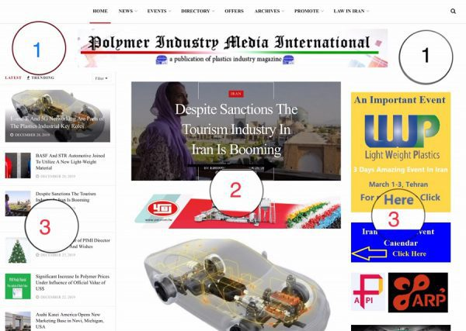
Table 2: Prices for positions at image 2
Position and Image Number | Maximum Dimension (width x height) | Minimum Order Month | Minimum size Accepted | Price Per Unit' GBP £ | Min. Estimated Price per month  £ | Estimated View Rate in 1-10 Seconds
Image 2
4 Above B2B News | 740 x 120 | 3 | 720 x 90 | 04.00 | 259.20 | % 60-70
5 Right | 350 x 200 | 12 | 320 x 100 | 06.00 | 192.00 | % 80
5 left - Top | 150 x 150  Note 2 | 2 | 150 x 150 | 40.00 | 900.00 | % 100
5 Left - Top | 350 x 200 | 2 | 320 x 100 | 30.00 | 960.00 | % 90
5 Left - Rest | 350 x 200 | 2 | 320 x 100 | 25.00 | 800.00 | % 80
6 Above International News | 740 x 120 | 3 | 720 x 90 | 04.00 | 259.20 | % 60-70
Image 2: The positions 4-6 for advertisements, mentioned at above table
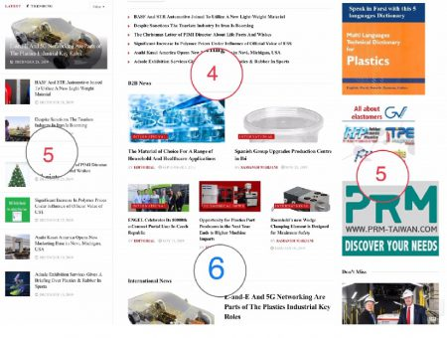
Table 3: Prices for positions at image 3
Position and Image Number | Maximum Dimension (width x height) | Minimum Order Month | Minimum size Accepted | Price Per Unit' GBP £ | Min. Estimated Price per month  £ | Estimated View Rate in 1-10 Seconds
Image 3
7 Above Random News | 740 x 120 | 6 | 720 x 90 | 03.50 | 226.80 | % 50-60
8 Right | 350 x 200 | 3 | 320 x 100 | 10.00 | 320.00 | % 70
8 Left | Note 3
9 Above International News | 740 x 120 | 4 | 720 x 90 | 06.00 | 388.80 | % 70-80
Note 3: All left positions correspond to the position 5 at the table 2
Image 3: The positions 7-9 for advertisements, mentioned at above table
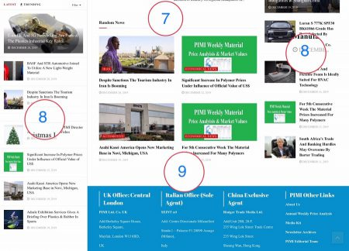

Table 4: Prices for positions at image 4 (For news reading pages, with unlimited scroll down)
Position and Image Number | Maximum Dimension (width x height) | Minimum Order Month | Minimum size Accepted | Price Per Unit' GBP £ | Min. Estimated Price per month  £ | Estimated View Rate in 1-10 Seconds
Image 4
10 Right Top | 350 x 200 | 3 | 320 x 100 | 15.00 | 480.00 | % 100
10 Right Rest | 350 x 200 | 6 | 320 x 100 | 10.00 | 320.00 | % 80-90
11 Left | Note 3
Image 4: The positions 10-11 for advertisements, mentioned at above table
Explanation for prices related to positions shown at images 5 -8 (For news reading pages, with unlimited scroll down)

5- Image 5 below:
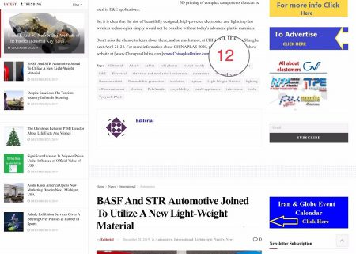
This is a position which corresponds to the end of each news per day. The customer can choose the number of adverts per 15 days. It will be appeared at the end of each news and will be inserted at least for 20-30 times per 15 days. But it could be seen as the readers scroll down the news pages. The rate for this advert is base on following table:
Position and Image Number | Maximum Dimension (width x height) | Minimum Order Days | Minimum size Accepted | Price Per Unit' GBP £ | Min. Estimated Price per 15 Days £ | Estimated View Rate in 1-10 Seconds
Image 5
12 Under Each News | 1100 x 300 | 15 | 900 x 100 | 5.00 | 450.00 | % 100

For more info please go to the next page

6- Image 6 below:
This is a position which corresponds to the top of the selected sectors of internal pages. The customer can choose the insertion 90 days. It will be appeared at the top of each sector and will be inserted one time for 90 days at the related sector like the event page.
Position and Image Number | Maximum Dimension (width x height) | Minimum Order Months | Minimum size Accepted | Price Per Unit' GBP £ | Min. Estimated Price per Month £ | Estimated View Rate in 1-10 Seconds
Image 6
13 Under Each News | 1100 x 300 | 3 | 900 x 100 | 4.00 | 360.00 | % 100

7- Image 7 below: (Next Page)
This is a very unique position which we have only 6 of it at the Iranian and 6 of it at the International sectors of the categorization of companies. The pages related to this position have had the highest rate of views and clicks since the start of this website. Any reader that refers to these pages, can see the advert for 100%. The adverts are accepted annually. The rate for this advert is base on the following table:
Position and Image Number | Maximum Dimension (width x height) | Minimum Order Months | Minimum size Accepted | Price Per Unit' GBP £ | Min. Estimated Price per Month £ | Estimated View Rate in 1-10 Seconds
Image 6
12 Under Each News | 900 x 450 | 12 | 900 x 100 | 10.00 | 900.00 | % 100

8- Image 8 below: (Next Page)
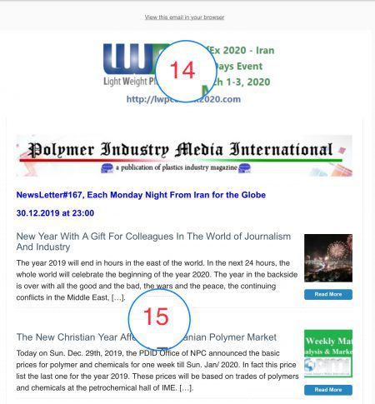
These are two unique positions belonging to the weekly newsletters of the PIMI. These newsletters are published every Monday nights at 23:00 and will be distributed among Iranian subscribers and all email addresses colected from exhibitors (all of them from the organizer source) and as much as possible collected from the visitors. At the end of 2019, the PIMI data bank has collected / updated more than 33,000 addresses. The average rate of the reaction of the newsletters receivers are as of following table extracted from the mailchimp reports:
Receiving Group | Ave. Opening Rate% | Ave. Bouncing Rate% | Ave. Clicking Rate% | Ave. Unsubscribing% Rate
Media | 72 | 3 | 28 | 2
Machinery | 67 | 13 | 33 | 1
Raw Materials | 55 | 9 | 41 | 5
Converting | 81 | 5 | 66 | 4
Mould and Equipment | 19 | 4 | 12 | 6
Others | 27 | 1 | 11 | 9
This means that, advertising at the weekly newsletters of PIMI could be more benefitiary, specialy with respect to the EVENT organizers, when they are looking fo more exhibitors and visitors. The rates for these two positions are
Position and Image Number | Maximum Dimension (width x height) | Min. --Max. Order weeks | Minimum size Accepted | Price Per Unit' GBP £ | Min. Estimated Price per weeks £ | Estimated View Rate in 1-10 Seconds
Image 8
14 Special Position at the header of the newsletter | 500 x 200 | 4 Note 4 | 300 x 100 | 10.00 | 300.00 | % 100
15 Positions after First News | 700 x 250 | 4 | 700 x 100 | 7.00 | 490.00 | % 25-100
Note 4: Each extra 4 weeks orders are entitled to 2% discount. Ex. A 12 weeks order is entitled to 4% discount.

Other notices:
1- All orders are subject to 100% payment after approval of the advert design;
2- All reservations are approved only if 20% of the total value is paid at the time of reservation;
3- All cancellation of the reserved positions are refundable by 50% only if are declared in written notice in 2 months in advance;
4- All paid adverts that should be cancelled due to any emergency are entitled to 50% payment for remaining period, only if requested by 2 months (or related minimum period) in advance written notice;
5- All other positions / dimensions are negotiable only if technically would be possible to accept.

