**TMA AUTOMATION Sp. z o.o., a subsidiary of the ENGEL Group, has begun construction of a modern office and production building in Gdansk, Poland.: New office and production building in Gdansk**

Schwertberg, Austria / Gdansk, Poland - 13 December 2024

**The ENGEL Group subsidiary, TMA AUTOMATION Sp. z o.o., has begun construction of a modern office and production building in the immediate vicinity of Gdansk Airport in Poland. This new location underlines ENGEL's commitment to growth and innovation in the automation of injection moulding processes.**

The strategically favourable location offers an excellent access to various educational and training institutions, including technical universities in the region. This supports the long-term recruitment of highly qualified specialists and strengthens the ENGEL Group's position in the field of highly integrated and automated production solutions.

The background to the new building is the planned growth of TMA AUTOMATION: the workforce is to be doubled in the medium term, creating new jobs and enabling the company to expand its capacities. This in turn will benefit our customers, particularly in Poland and Eastern Europe, as TMA AUTOMATION prefers to manufacture customised automation solutions for these regions.

*"With this new building, we are laying the foundation for further growth and ensuring that we can meet our customers' increasing demand for automation solutions even better,*" explains Walter Aumayr, Vice President Post Merger Integration of the ENGEL Group and Managing Director at TMA AUTOMATION.

**Investing in the future**

ENGEL acquired a majority stake in TMA AUTOMATION in 2022. The new building in Gdansk will intensify the collaboration between the two companies. TMA AUTOMATION remains active on the market as an independent brand. While the founders Marek Łangowski and Piotr Orlikowski will continue to manage the business, Walter Aumayr will supplement the local management team and strengthen the connection to the ENGEL Group.

*"This investment clearly demonstrates our commitment to the region and our goal of driving innovation in automation,*" emphasises Dr Stefan Engleder, CEO of the ENGEL Group. *"Automation is a central pillar of our strategy, with which we offer our customers efficient and forward-looking solutions. The new building in Gdansk is a key milestone in our long-term planning and a strong symbol of the successful partnership between ENGEL and TMA AUTOMATION."*

**TMA AUTOMATION: Partner for automation in injection moulding**

TMA AUTOMATION specialises in the development and implementation of innovative and customer-specific automation solutions, particularly in the areas of in-mould labelling (IML), side-entry robots, palletising systems and stand-alone assembly systems. In the new building, TMA will continue to develop customised solutions to meet customers' growing requirements and ensure maximum flexibility.

*"TMA's experience and expertise ideally complement ENGEL's ability to offer customised automation solutions for even more technologies from a single source. In addition, TMA AUTOMATION is an important and highly flexible local automation partner for our customers in Poland and throughout Eastern Europe,"* says Jörg Fuhrmann, Vice President Automation of the ENGEL Group.

The partnership between ENGEL and TMA began long before the majority shareholding in 2022. Together, the companies have successfully implemented numerous projects, significantly increasing production capacities and customer efficiency. The new building, which is scheduled for completion by autumn 2025, will further strengthen this collaboration to meet the increasing demand for sustainable and high-performance automation solutions.

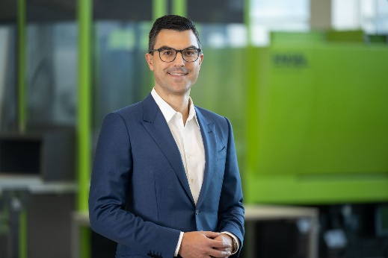

Stefan Engleder, CEO ENGEL Group (Photo: ENGEL)

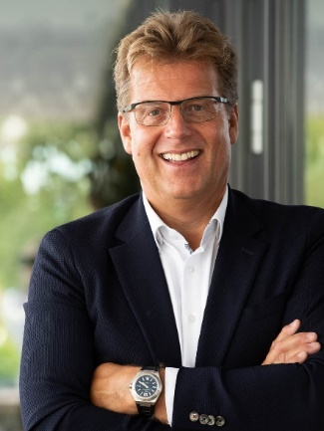

Walter Aumayr, Vice President Post Merger Integration of the ENGEL Group and Managing Director of TMA AUTOMATION

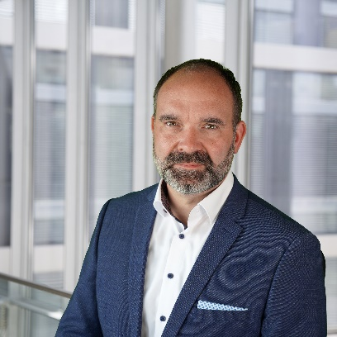

Jörg Fuhrmann, Vice President Automation ENGEL Group

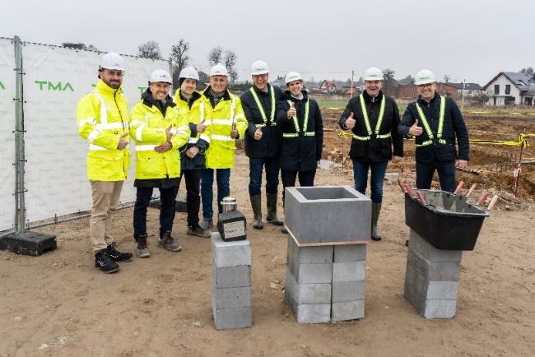

The TMA and ENGEL team at the ground-breaking ceremony for the new building in Gdansk (Photo: TMA AUTOMATION)

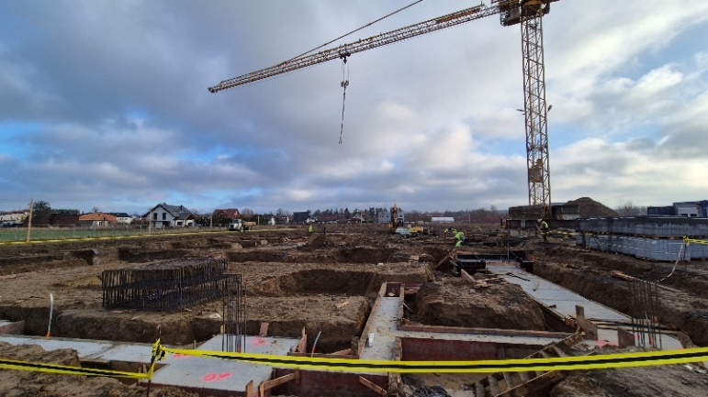

Construction of the new office and production building has already begun. (Photo: TMA AUTOMATION)

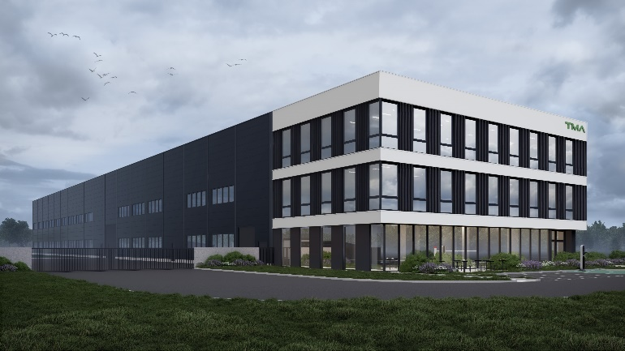

Rendering of the planned office and production building in Gdansk (Photo: TMA AUTOMATION)

ENGEL AUSTRIA GmbH

ENGEL is one of the global leaders in the manufacture of injection moulding machines. Today, the ENGEL Group offers a full range of technology modules for plastics processing as a single source supplier: injection moulding machines for thermoplastics and elastomers together with automation, with individual components also being competitive and successful in the market. With ten production plants in Europe, North America, Mexico and Asia (China and Korea), and subsidiaries and representatives in more than 85 countries, ENGEL offers its customers the excellent global support they need to compete and succeed with new technologies and leading-edge production systems.

Contact for journalists:

Anna Sterrer, Head of Group Communications, ENGEL AUSTRIA GmbH,   
Ludwig-Engel-Straße 1, A-4311 Schwertberg/Austria,   
Tel.: +43 (0)50/620-73817, E-Mail: anna.sterrer@engel.at

Tobias Neumann, Press Officer, ENGEL AUSTRIA GmbHLudwig-Engel-Straße 1, A-4311 Schwertberg, Austria Tel.: +43 (0)50 6207 3807; e-mail: [tobias.neumann@engel.at](mailto:tobias.neumann@engel.at)

Contact for readers:

ENGEL AUSTRIA GmbH, Ludwig-Engel-Strasse 1, A-4311 Schwertberg, Austria,   
Tel.: +43 (0)50 620-0, Fax: -3009, E-Mail: sales@engel.at

Legal notice:  
The common names, trade names, product names and similar cited in this press release are protected by copyright. They may also include trademarks and be protected as such without being specifically highlighted.

[www.engelglobal.com](http://www.engelglobal.com)